Wildfire en US, data Analysis
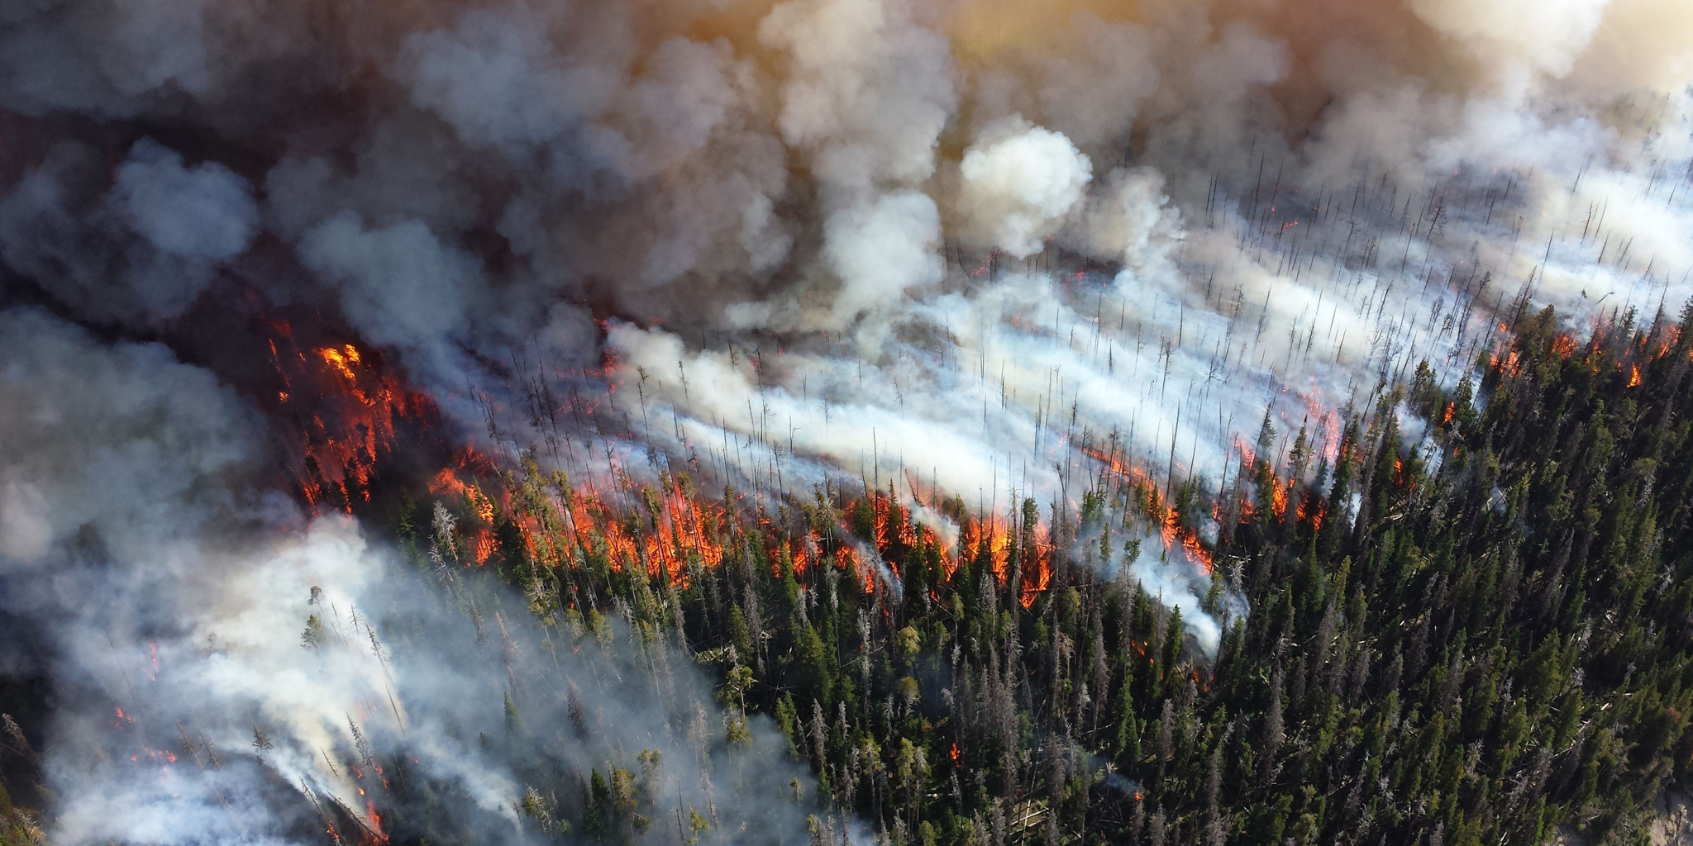

Wildfires are among the greatest global threats, and this threat continues to grow due to the combined influence of human factors such as population expansion and the changes people have introduced into ecosystems. Wildfires pose serious risks to ecosystems, biodiversity, human quality of life, and infrastructure. They also represent one of the most significant threats to the productive forestry industry.
Climate change has further intensified this danger by increasing the frequency and severity of wildfires, altering temperature patterns, reducing humidity and precipitation, and extending the fire season both temporally and spatially.
It is also important to distinguish between a wildfire and a prescribed burn, as they often have completely opposite effects. A wildfire is defined as an unplanned, unwanted fire burning in a natural area such as a forest, grassland, or prairie. This includes unauthorized human-caused fires, escaped wildland fire-use events, escaped prescribed burns, and any other wildland fire where the main objective is suppression.
In contrast, a prescribed or controlled burn is intentionally conducted under carefully managed conditions to ensure safety. Its purposes may include reducing fuel loads to lower wildfire risk, preparing land for new crops, or promoting biodiversity. These burns are carried out only under very specific weather conditions and by highly trained personnel.
In this project, we analyzed a dataset containing 2.3 million wildfire records from the United States, with the goal of applying the regression and classification tools learned in class. In the first part, after preprocessing the data, we conducted an exploratory analysis to better understand the wildfire problem, examine the structure of the dataset, and assess the presence of multicollinearity among the variables.
1.- Dataset
The data used in this analysis correspond to a database of 2.3 million wildfire records in the United States, spanning the years 2004 to 2020. Each observation (row) contains 49 variables. From these, we selected the wildfire size—both as a continuous measure and as a categorical class—as the target variable, while the remaining variables were considered as potential predictors.
We discarded columns with little or no useful information, as well as those deemed irrelevant for the purposes of this study. After this selection process, the dataset was reduced to the following predictor variables:
- FIRE_YEAR: Year in which the wildfire occurred.
- DISCOVERY_DATE: Date on which the wildfire was first detected.
- DISCOVERY_DOY: Julian day corresponding to the detection date.
- NWCG_CAUSE_CLASSIFICATION: Cause classification according to the categories defined by the National Wildfire Coordinating Group (NWCG).
- NWCG_GENERAL_CAUSE: A more detailed sub-classification of the wildfire cause, also defined by NWCG guidelines.
- LATITUDE, LONGITUDE: Geographic coordinates of the wildfire ignition point.
- FIRE_SIZE: Wildfire size measured in acres.
- FIRE_SIZE_CLASS: Categorical size class of the wildfire.
- OWNER: Type of landowner or managing agency where the wildfire originated.
- STATE: U.S. state in which the wildfire started.
To reduce noise in the analysis and exclude prescribed burns that may have been mistakenly recorded as wildfires, we filtered the dataset to retain only events larger than 100 acres. After the data cleaning and preprocessing steps, the resulting dataset consisted of 60,713 records.
Additionally, we appended the maximum temperature for the day and location of each wildfire ignition, extracted from the Open-Meteo web API.

Exploratory Analysis
The exploratory analysis allows us to gain a deeper understanding of the wildfire problem, examine the structure of the dataset, and assess the presence of multicollinearity among the variables.
We begin with a summary of the basic descriptive statistics, followed by an overview of some of the variables
Basic descriptive statistics
The first step is to analyze the number of fires and their size by year, and to better understand the trend visually, we have created this chart:
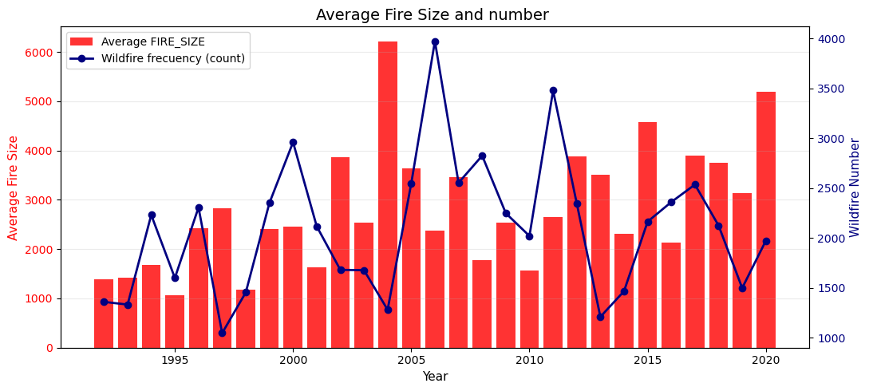
The chart indicates that, although the annual number of wildfires does not exhibit a consistent trend over time, the average fire size demonstrates a clear upward trajectory, suggesting an increase in fire severity and extent in recent years.

Fire Size Distribution

The distribution of fire size classes in the dataset is highly imbalanced. Each class represents an ordinal category, with Class D (smallest fires in our dataset) being the most frequent, followed by Class E, and so on, up to Class G, which corresponds to fires exceeding 5,000 acres. It is important to note that Classes A, B, and C—representing fires smaller than 100 acres—were removed from the dataset prior to this analysis.

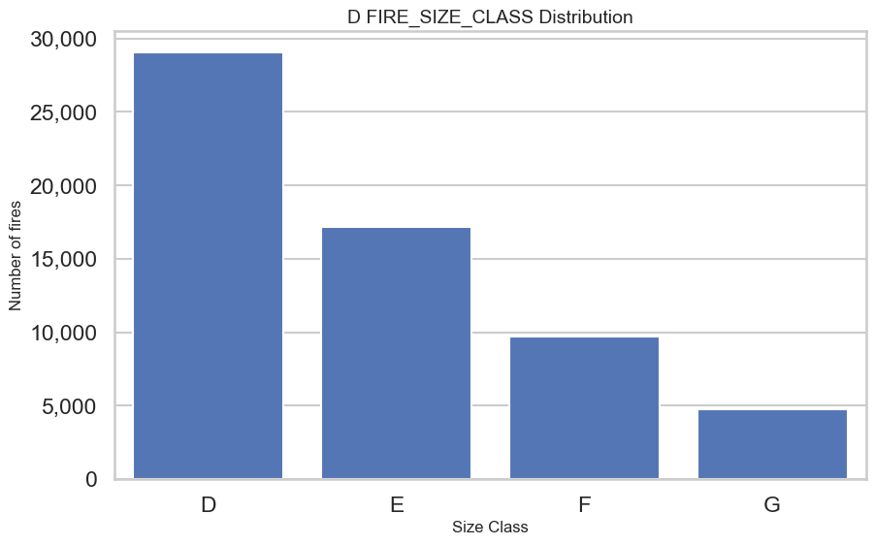
Understanding this imbalance is critical for modeling and interpretation, as it may affect classification performance and bias toward the majority class.

Main Causes of Wildfires
In addition to size distribution, identifying the primary causes of wildfires is essential for understanding the underlying drivers and for developing effective prevention strategies. According to our dataset, natural causes rank first as the leading ignition source, which contrasts with patterns observed in other regions. The most significant natural cause is lightning strikes. However, when aggregating human-related causes—classified broadly into intentional and negligent actions—the combined total far exceeds that of natural causes.
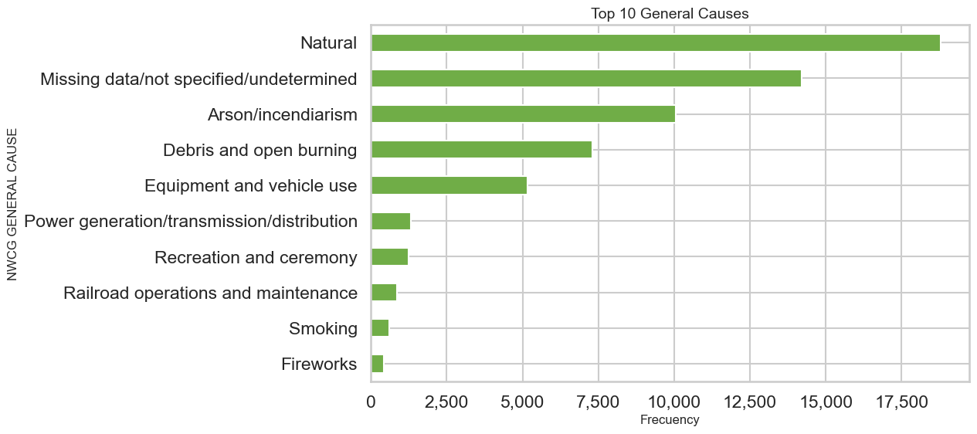
This insight highlights the importance of distinguishing between natural and anthropogenic drivers when designing prevention and mitigation strategies, as human activity remains the dominant contributor overall despite the prevalence of lightning as a single cause.

Seasonality of Wildfires
It is also important to explore the seasonal patterns of wildfire occurrence. To do this, we plotted the frequency of fires aggregated by month. As expected, the highest concentration of wildfires occurs during the summer months. However, the data also reveals a notable bimodal pattern, with an initial peak in March followed by a second peak in July.
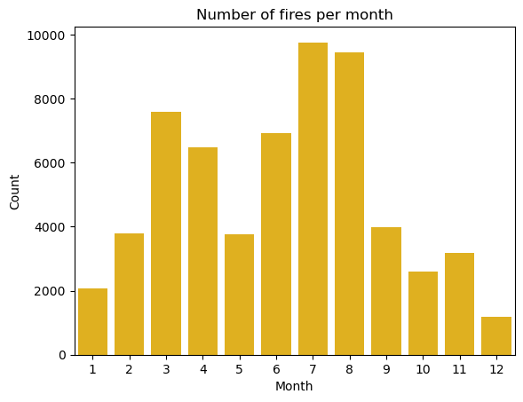
This seasonal variability may reflect regional climatic conditions, fuel availability, and human activity patterns, and should be considered when developing predictive models and management strategies.

